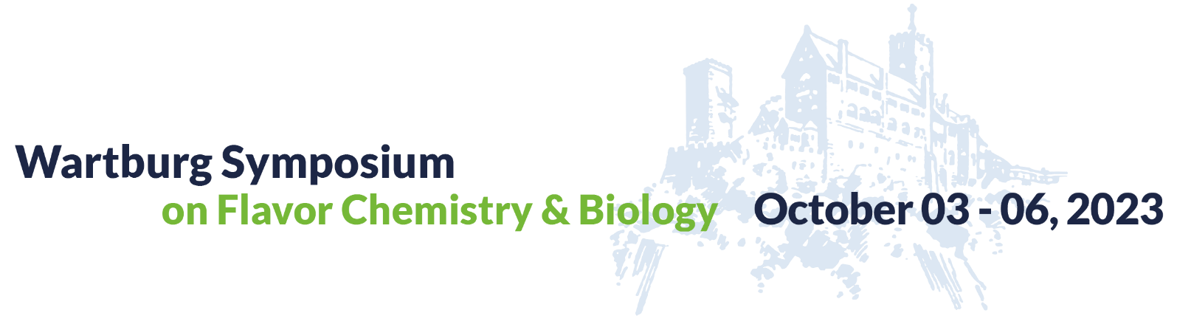

Nestlé Award for Excellence in Flavor Science

Submission Template

Your Name:

Your Email Address

Affiliation

Position
Main field of research

Confirm that an abstract has been accepted at the 2023 Wartburg Symposium and that you will be present.
Provide abstract number and letter of acceptance from the Symposium organizers.

Please attach:
- Curriculum Vitae
- Recent academic transcripts
- List of publications
- Two reference letters from senior scientists
- Abstract number and letter of acceptance from the Symposium organizers
In the next pages, please briefly describe the scientific discovery or the results for which you seek the Wartburg Excellence Award in Flavor Research and explain why you believe your work :
- can be used to overcome current challenges in the agri-food-nutrition sector, and/or
- can be translated into innovative products & services in the food industry.
Please do not submit any confidential information. For instance there is no need to provide us with the name of any business partner or any sensitive commercial information. In case your results or discovery are patentable but you have not yet filed a patent application, you should obtain professional advice before any public disclosure, so as not to endanger the patentability of your work
Size limit of answers: Please be succinct. Do not exceed 300 words per answer for each question.

Brief Description of your results/discovery:

Scientific excellence: Please explain why the scientific challenge that you tackle is difficult and high level.

Can your work be used to overcome current challenges in the agri-food-nutrition sector and/or have your results already been translated into innovative products & services for the food industry? If not, do you expect your results will lead to innovative products or services? Why? Please provide convincing evidence.

Is your solution innovative in comparison to what is already available on the market? Why? How?

Is your solution relevant to market needs? Please explain why and how.

Is your solution commercially feasible? Please justify your answer.

Entrepreneurship: Have you already or are you planning to take entrepreneurial or other commercial steps towards turning your idea into reality? Please describe your action plan.

Application process:

Candidates must apply using this template and send electronically their application to the Wartburg Symposium Organizers by February 28, 2023.

Additional conditions:
- Nestlé respects your privacy. Nestlé requests information with this application for the purpose of identifying future talent in the food industry and awarding the Wartburg Excellence Award in Flavor Research. Please read our Privacy Notice at https://www.nestle.com/aboutus/businessprinciples/privacy.
- You confirm that the information in this application form is true and correct and represents your original work, that you are fully authorized to present it to the Wartburg Symposium Organizers and Nestlé, and that you have not included confidential information.
- With submission of the application, the applicant accepts these conditions.

